# Git hooks are scripts that automatically run every time a particular event occurs in a Git repository. They let you customize Git’s internal behaviour and trigger customizable actions at key points in the development life cycle

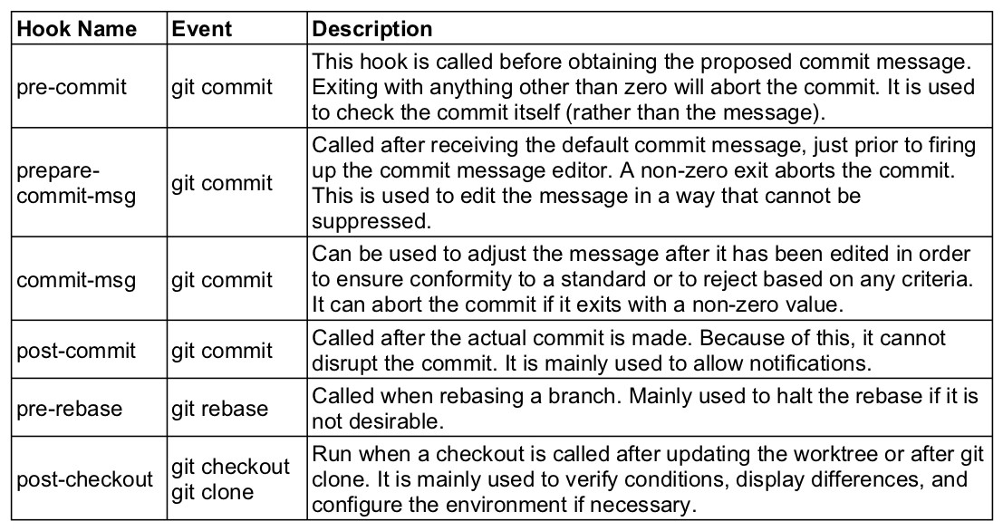

1. Create or Initialize empty git repository (git init)
2. You will find .git folder 🡪 hooks

1. To activate git hooks 🡪 just remove .sample extension

1. Before committing the content of pre-commit will get execute and based on the result of file either commit will be successful or fail

1. Stage the contents and commit the changes

1. Observe “About to commit….” message coming from that file (pre-commit see below)

